Emotion Detection using Twitter Datasets and Spacy Algorithm

Now-a-days almost all peoples are using social media to express their views on any topics such as movie, politics, sports and many more. Using this social media text we can find important knowledge about which political parties are doing well or which products in the market are giving performance.

This online social media views or review are in huge quantity and they contain unstructured text messages which cannot be used manually to extract important knowledge.

To overcome from this problem we are using Machine Learning and Natural language processing algorithm such as SPACY to extract important knowledge in terms of emotion. Peoples reviews often contains emotions, if they satisfy then their review will show positivity, if not satisfy then it will contains negativity or neutral. In propose work to extract such emotion we are using online Tweeter tweets messages and then applying SPACY natural language processing algorithm to clean tweets by removing special symbols, stop words, stemming etc. This processed tweets will be apply to machine learning algorithm to predict emotion such as positive, negative or neutral.

To implement this project we have used below tweets messages

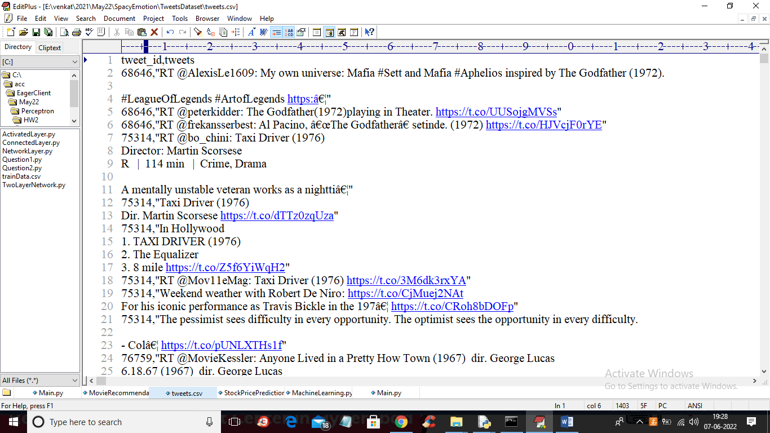

In above dataset we can see tweets messages contains special symbols and stop words and unstructured data so by applying SPACY module we can clean above text and then detect emotion from it.

To implement this project we have designed following modules

1. Upload Tweets Dataset: using this module we will upload tweets messages to application
2. Preprocess Dataset using Spacy: using this module we will read each tweets and then apply spacy algorithm to clean and processed tweets
3. Load Emotion Detection Model: using this module we will load emotion detection machine learning algorithm
4. Emotion Detection from Processed Tweets: using this module we will apply each processed tweet on machine learning model which will predict emotion from given tweet
5. Emotion Graph: using this module we will plot emotion graph from all tweets

SCREEN SHOTS

To run project double click on ‘run.bat’ file to get below screen

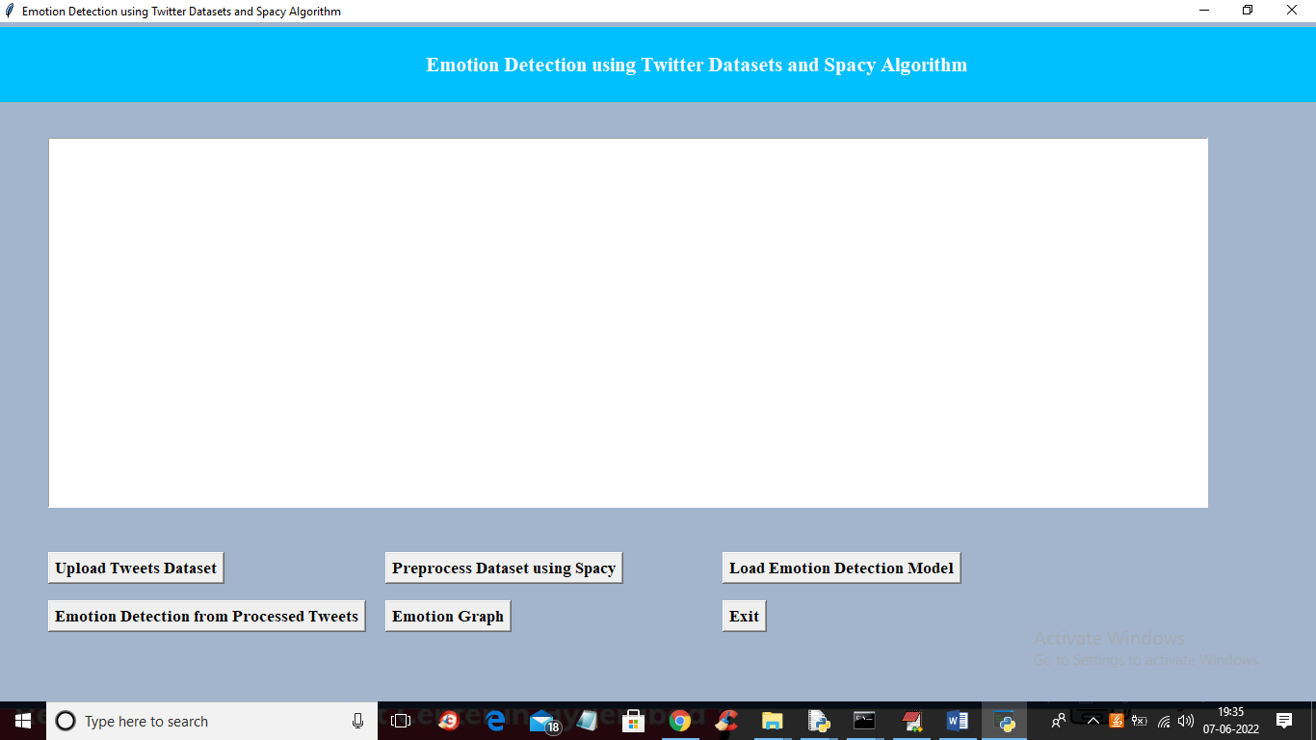

In above screen click on ‘Upload Tweets Dataset’ button to load tweets and get below output

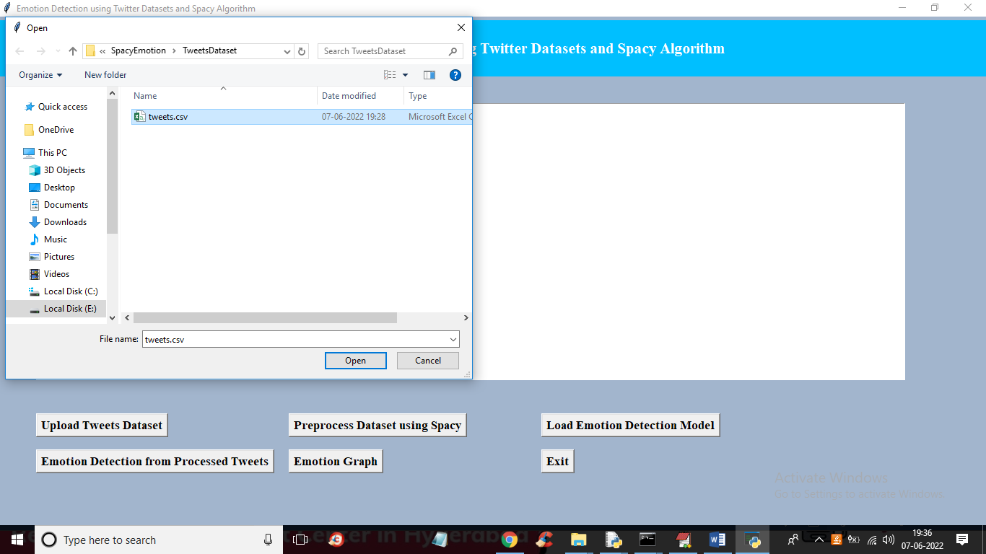

In above screen selecting and uploading tweets dataset and then click on ‘Open’ button to get below output

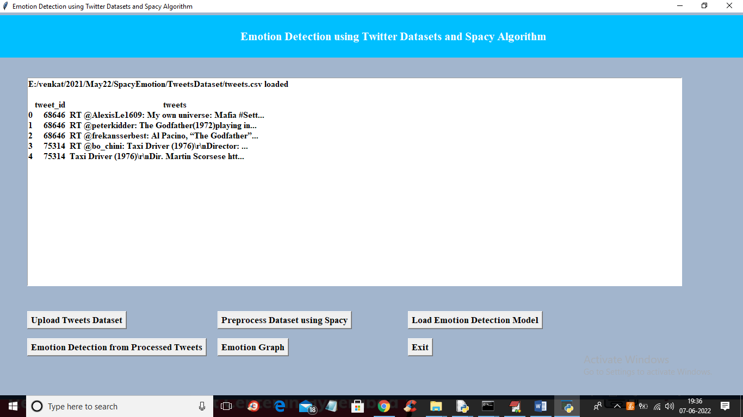

In above screen we can see dataset loaded and tweets contains total unstructured text with stop words and special symbols and now click on ‘Preprocess Dataset using Spacy’ to clean tweets and get below output

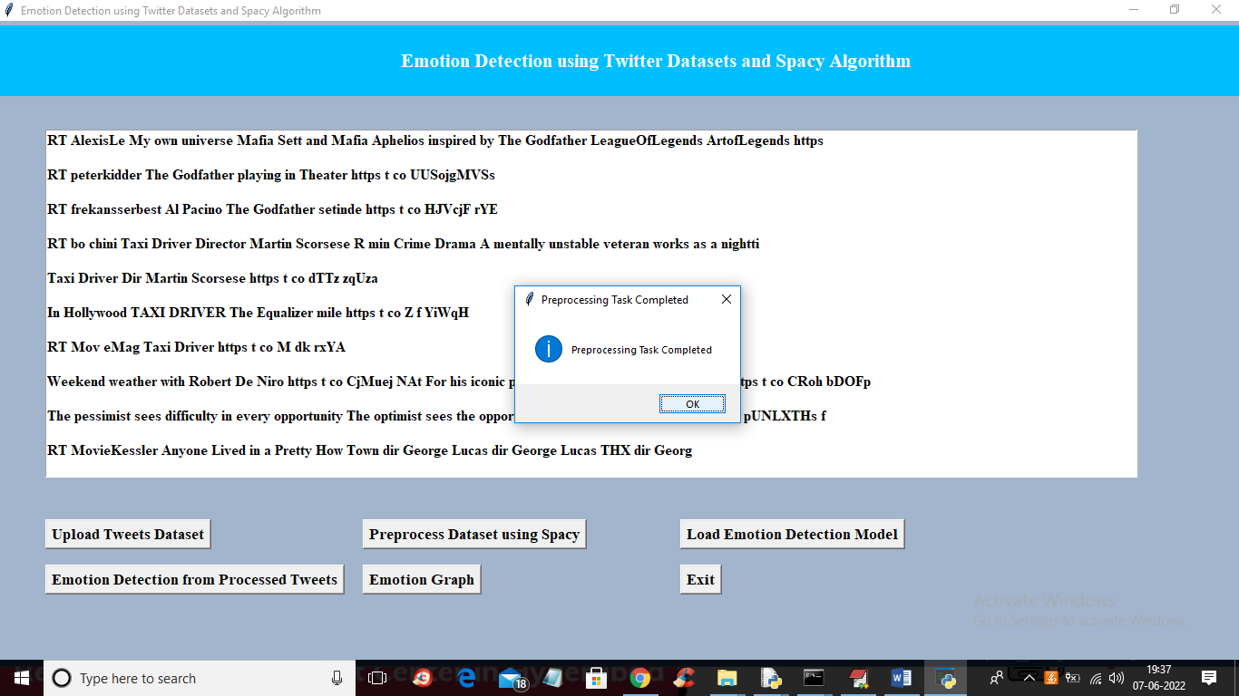

In above screen Preprocessing completed and we can see all tweets contains only text with clean words and now click ‘Ok’ button and then click on ‘Load Emotion Detection Model’ button to load machine learning model for emotion detection and get below output

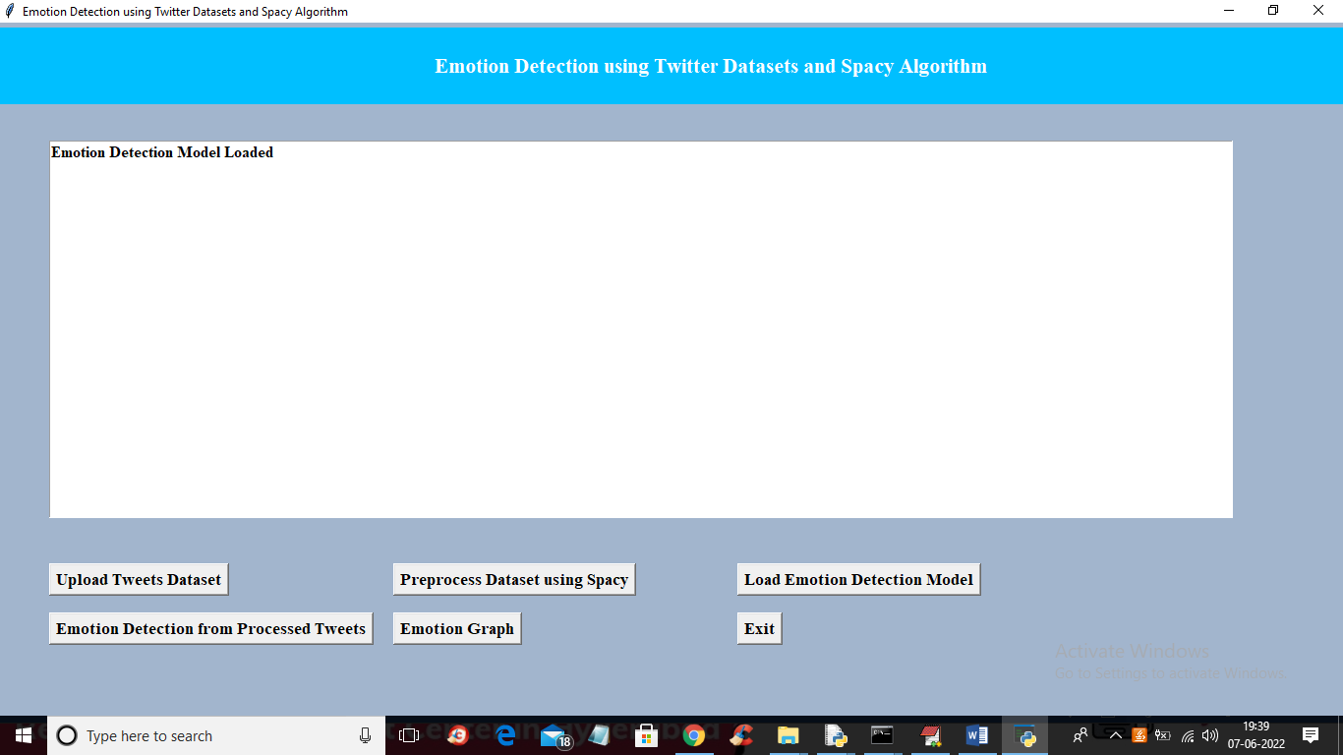

In above screen model is loaded and now click on ‘Emotion Detection from Processed Tweets’ button to detect emotion and get below output

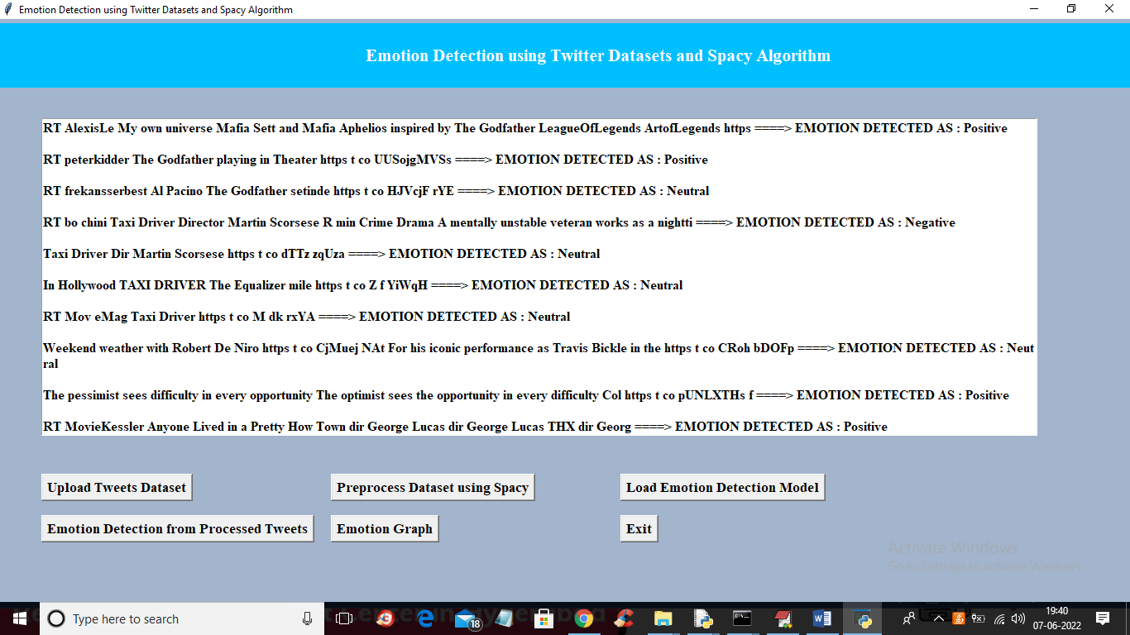

In above screen before arrow symbol =🡺 we can see clean tweet messages and after arrow symbol we can see predicted emotion as ‘Positive, Negative or Neutral’ and scroll down above screen to view all messages

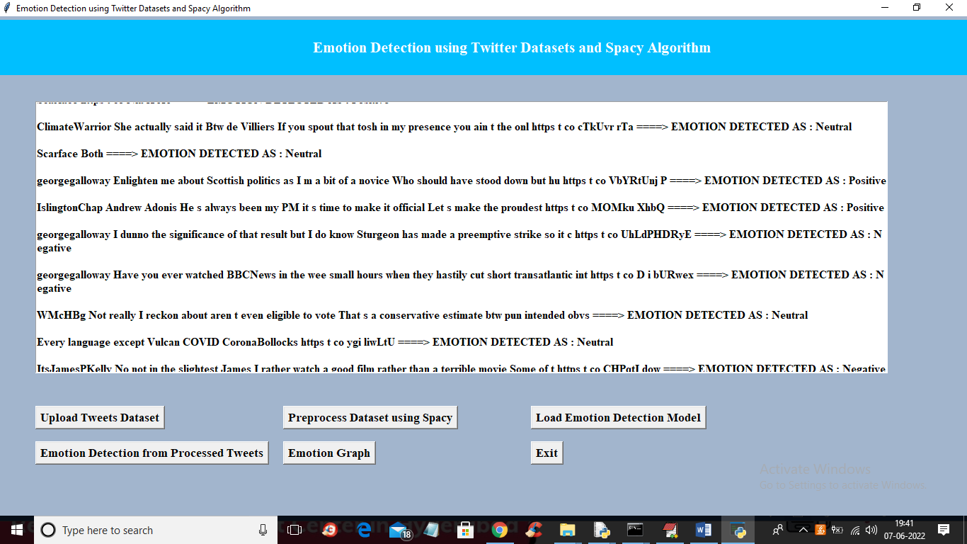

In above screen we can see all tweets with emotion and now click on ‘Emotion Graph’ to know tweets percentage in each emotion

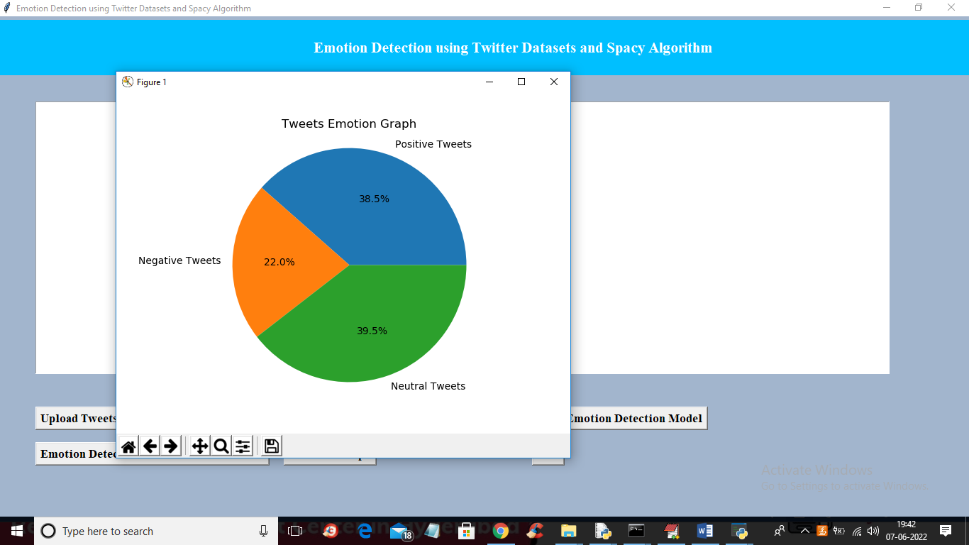

In above graph 38.5% peoples are giving positive tweets and 22% gave negative tweets and 39.5% gave neutral tweets so by using this application we can easily extract useful knowledge from peoples reviews weather they are satisfy or not on any topics tweets